Specification
  - BERx-ISc-0048 Request for Quote - Requested Date as Required Field
Doc Version 1.0

Customer: | - Berents Gmbh & Co. KG
Project: | In Base
Proalpha version: | 7.2.0
Proalpha Installation(s): | DE
Product variant: | ∑ Proalpha ray  ☒ Proalpha classic  Note: If "Proalpha ray" is enabled, the following are possible Always a conversion in the classic client.
GUI language: | German
Author: | Ines Schmidt
Created on: | 03.06.2025
Last change on: | 03.06.2025
Contact person customer: | Mr. Hartmann

This document describes a customization or expansion of the standard software in Proalpha in the product variant defined above and has been checked by the customer. The technical design in Chapters 2 - 4 is hereby released in compliance with the requirements of the "Final Provisions" section of the technical specification and costing:

............................................
Date and signature customer

Contents
1. [UPDATE THE TABLE] 3
1.1 [UPDATE THE TABLE] 3
1.2 [UPDATE THE TABLE] 3
1.3 [UPDATE THE TABLE] 3
1.4 [UPDATE THE TABLE] 3
2. [UPDATE THE TABLE] 4
2.1 [UPDATE THE TABLE] 4
2.2 [UPDATE THE TABLE] 5
3. [UPDATE THE TABLE] 6
3.1 [UPDATE THE TABLE] 6
4. [UPDATE THE TABLE] 7
4.1 [UPDATE THE TABLE] 7
4.2 [UPDATE THE TABLE] 7
4.3 [UPDATE THE TABLE] 7
5. [UPDATE THE TABLE] 8
5.1 [UPDATE THE TABLE] 8
5.1.1 [UPDATE THE TABLE] 8
5.1.2 [UPDATE THE TABLE] 8
5.1.3 [UPDATE THE TABLE] 8
6. [UPDATE THE TABLE] 9
7. [UPDATE THE TABLE] 10
7.1 [UPDATE THE TABLE] 10
7.2 [UPDATE THE TABLE] 10
8. [UPDATE THE TABLE] 11

Requirements

References
The specifications were created due to the requirements of Mr. Kennert (Purchasing).

Summary and objective
In the request for quote, the Requested Date field is to be made a mandatory field.
ควรทำใน Trigger หรือ domain standard โดยตรง

Request Description

Request Glossary (Term Statement)

Term | Explanation
Table 1: request glossary

Professional design

Solution summary

Business logic & GUI
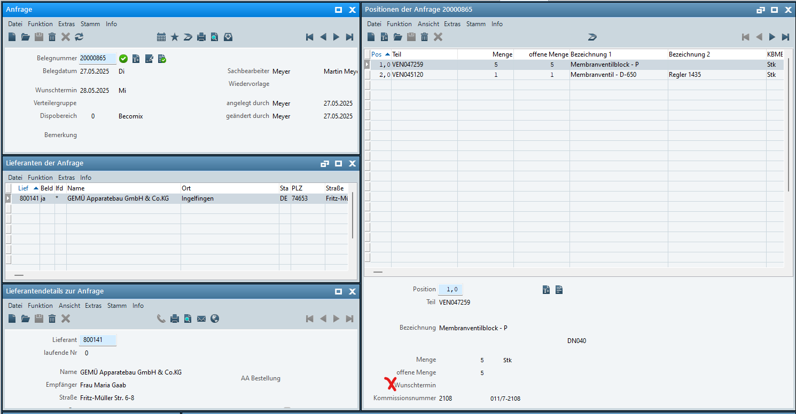
The Requested Date field is to require a required entry.
ช่อง Wunschtermin (Date) บังคับว่าต้องกรอกให้ครบถ้วน
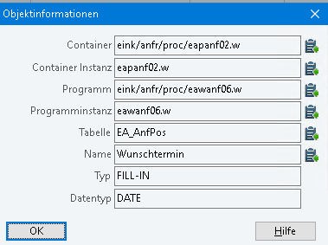
- If the user wants to save a request line without a requested date, this has to be blocked by a system message "The entry of the requested date is required."
ถ้ากรอกข้อมูลโดยไม่ใส่ข้อมูลวันที่ จะขึ้น message เตือน
- This is an error message, so only the OK button is to be available.
error message มีปุ่ม ok ให้กด

Data model
None

Output
None

Accruals and deferrals
The adjustment refers to the tables, fields and programs mentioned.
These specifications do not automatically add functional enhancements to adjacent modules of the Proalpha environment, such as DMS, Analyzer, reports, and forms. The Proalpha Help is not automatically expanded.
Changes to adjoining modules/programs have to be described and defined in the functional specifications. It also includes changes to the GUI. If Ray is not specifically mentioned here, this customization refers to the Classic Proalpha client.

Test cases
The specified test cases map the adjustment described here and are the basis for the acceptance of the software.

Save RFQ Line
Pt | Explanation | Expected result | Test data
 | Creating a request line without entering a requested date  Saving | The error message appears, it cannot be saved.
 | Test result (incl. screenshots)
 | Entering a requested date  Saving | The error message does not appear, it can be saved.
 | Test result (incl. screenshots)
 | Opening an existing request line without requested date (legacy data situation)  Saving | The error message appears, it cannot be saved.
 | Test result (incl. screenshots)

Prerequisites

Technical requirements
The use of Proalpha functionalities outside the Concurrent User Model (connection of external systems, background processing) requires the licensing of so-called software services.
"Using Proalpha functionalities" refers to any use or access to the Proalpha infrastructure, e.g.
None

Organizational requirements
None

Notes about the commissioning
None

Technical design

<Template for Section>

GUI

Business logic

Data model

Final provisions
These specifications form the basis for customer-specific expansions of the standard software Proalpha®.
The customer-specific extensions only cover the category defined in this specification. Functionality beyond this scope is not provided.
Unless expressly agreed otherwise, the customer-specific extensions are only created in German: no programs, program parts or data are translated into other languages. This also applies to the languages supported by Proalpha® in the standard version.
The customer-specific expansions are carefully tested before they are delivered. However, for technical reasons, it is not possible to perform the test under the same conditions and with the same data that will be used by the customer. It is therefore recommended to carefully check the functions after they have been delivered in the real system environment.
The Customer understands that variances in the display details or handling of the features defined in this Statement of Work may be required for the transfer of the features defined in this Statement of Work to new versions of Proalpha®. This specification also remains valid in this case, provided that there is a maintenance agreement for the customer-specific extensions defined in this specification and no changes to the functionality have to be agreed on.
This specification documents the customer-specific expansions. No other documentation beyond that contained in this SOW shall be provided. Questions about customer-specific expansions are received and forwarded by the hotline.
By signing on page 1, you confirm:
- that the specification is accepted in this version and becomes part of the contract,
- that this specification defines the functional scope of the software to be created and that there are no side agreements regarding the functionality,
- that a technical specification is created for the functional specification, which is then invoiced separately if the quote is not ordered in the context of the quote validity for the implementation of the functional specification.

Appendix

Table of Figures
No entries could be found for a table of figures.

Table of tables
[UPDATE THE TABLE] 3

Change history
Doc -  Version | Date | Contact | initiator | Chapter | Explanation
1.0 |  | Ines Schmidt | Mr. Hartmann | All | Initial new entry

